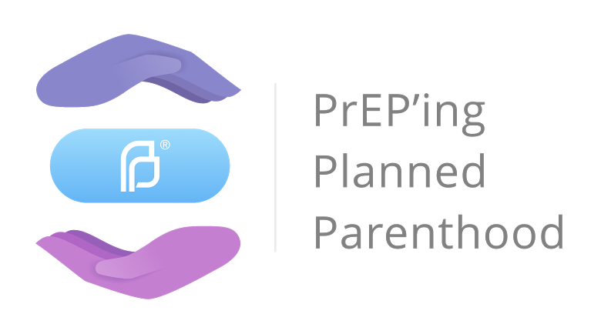

PrEP Consultation & Follow-Up Checklist

PREP CONSULTATION (INITIAL PREP VISIT AFTER INTAKE)

Key Discussion Points To Cover
PrEP is medication to substantially reduce risk of HIV infection
- PrEP is highly effective (over 90%) but may not be 100% effective

PrEP works by preventing the HIV virus from taking hold in the body

PrEP involves one pill (Truvada®) taken once daily
        - Must be taken every day to be most effective

PrEP does not protect against other STIs (including hepatitis C) or pregnancy
        - PrEP plus condoms recommended for maximum protection against HIV, other STIs, and pregnancy

Follow-up appointment required every 3 months
        - Need to test for HIV on ongoing basis, since PrEP alone is not sufficient for HIV treatment for people who are HIV+

PrEP is not a lifelong commitment
        - PrEP use may change as life circumstances and risk for HIV change

PEP following high-risk exposure may be useful if not at ongoing risk or if taking PrEP but miss repeated doses

Patient Questions and Concerns
Ask about and address patient questions and concerns about PrEP

Baseline Labs to Perform
HIV Screening
- 4th-generation HIV-1/2 Ag/Ab test – rapid or blood/lab test
- If patient is suspected to have primary (acute) HIV infection, also order a plasma HIV RNA assay (viral load). This requires a frozen specimen so it is best to have patient go to local Quest lab and have drawn there.

Other STI screening
- Hepatitis B Ag/Ab
- Hepatitis C Ab
- Chlamydia (urethral, rectal, pharyngeal)
- Gonorrhea (urethral, rectal, pharyngeal)
- Syphilis

Pregnancy test (if applicable)

Creatinine with GFR: This can be used to calculate the creatinine clearance (eCrCL)

Vaccinations to Offer
        - Offer Hepatitis A vaccine to all MSM
        - Offer Hepatitis B vaccine to all patients if titer shows that patient is not immune
        - Offer Gardasil to all patients if age appropriate

PrEP Eligibility Criteria to Confirm BEFORE starting PrEP
Confirmed HIV-negative within 7 days of PrEP start
- If HIV-positive, refer to HIV or infectious disease specialist (DO NOT START PREP)

18+ years of age

NOT pregnant or planning to be
- If pregnant or planning to be, patient should be referred to HIV or infectious disease specialist for PrEP management

PrEP Eligibility Criteria to Confirm WITHIN 48 HOURS OF starting PrEP:
eCrCL > 60 ml/min
- If eCrCl < 60 ml/min or other health conditions that threaten renal safety, patient should be referred to HIV or infectious disease specialist for PrEP management
- If patient has known kidney impairment or has risk factors for kidney disease, wait until creatinine result is received and confirmed to be in normal range before initiating PrEP

No active hepatitis B
- If active infection exists, patient should be referred to HIV or infectious disease specialist for PrEP management

Prescription and Follow-Up Plans
Write prescription for emtricitabine/tenofovir disoproxil fumarate with 200mg/300mg (Truvada®) oral tablets (30-day supply)
Review common side effects of medication with patient
Review symptoms of primary (acute) HIV infection and instruct patient to seek HIV testing right away if observed
Advise patient that PrEP drug levels are not fully protective for 7-14 days (anal sex) or 21 days (vaginal sex)

Support patient in applying for financial assistance programs (to cover uninsured or offset insurance co-pay)
Provide educational materials about PrEP
Instruct patient to schedule 1-month follow-up appointment and to call with any questions/concerns or if they decide to discontinue in the meantime

1-MONTH FOLLOW-UP APPOINTMENT

Key Discussion Points To Cover
Overall experience and attitudes related to PrEP

Side effects experienced

Adherence

Any signs or symptoms of primary (acute) HIV infection

Sexual activity and condom use

Patient Questions and Concerns
Ask about and address patient questions and concerns about PrEP

Labs to Perform
HIV Screening
- 4th-generation HIV-1/2 Ag/Ab test (rapid or blood/lab test)
- If patient is suspected to have primary (acute) HIV infection, also conduct plasma HIV RNA assay (viral load)

Creatinine with GFR to calculate creatinine clearance (eCrCL)

Other STI screening based on risk factors
- Hepatitis C Ab
- Chlamydia (urethral, rectal, pharyngeal)
- Gonorrhea (urethral, rectal, pharyngeal)
- Syphilis
- (No need to repeat Hepatitis B labs as long as patient is immune)

Pregnancy test (if applicable)

Prescription and Follow-Up Plans
Write prescription for emtricitabine/tenofovir disoproxil fumarate with 200mg/300mg (Truvada®) oral tablets (60-day supply)
Instruct patient to schedule follow-up appointment in 2 months (3 months since starting the medication) and to call with any questions/concerns or if they decide to discontinue in the meantime.

FOLLOW-UP APPOINTMENTS EVERY 3 MONTHS

Key Discussion Points To Cover
Overall experience and attitudes related to PrEP

Side effects experienced

Adherence

Any signs or symptoms of primary (acute) HIV infection

Sexual activity and condom use

Patient Questions and Concerns
Ask about and address patient questions and concerns about PrEP

Labs to Perform
HIV Screening
- 4th-generation HIV-1/2 Ag/Ab test (rapid or blood/lab test)
- If patient is suspected to have primary (acute) HIV infection, also conduct plasma HIV RNA assay (viral load)

Creatinine with GFR to calculate creatinine clearance (eCrCL)
- Order at least every 6 months
- Order more frequently if patients taking other medications that could affect kidney function (Lisinopril, acyclovir, valcyclovir, NSAIDs) or if they have any chronic conditions that could impair kidney function (diabetes, hypertension)

Other STI screening based on risk factors:
- Hepatitis C Ab
- Chlamydia (urethral, rectal, pharyngeal)
- Gonorrhea (urethral, rectal, pharyngeal)
- Syphilis

Pregnancy test (if applicable)

Prescription and Follow-Up Plans
Write prescription for emtricitabine/tenofovir disoproxil fumarate with 200mg/300mg (Truvada®) oral tablets (90-day supply)
Instruct patient to schedule 3-month follow-up appointment and to call with any questions/concerns or if they decide to discontinue in the meantime

DISCONTINUATION
Strongly encourage face-to-face discussion with provider before stopping

Continue PrEP for four weeks after the last potential HIV exposure

If PrEP discontinued for > 7 days, repeat HIV testing prior to restarting

Recommend periodic patient follow-up to restart PrEP as needed

This checklist was adapted from protocols developed by Dr. Krystn Wagner (October of 2015) and Planned Parenthood Federation of America (June 2016) and is considered best practice as of July 2017. The checklist may be modified by the PrEP’ing Planned Parenthood research team in the future as standards and scientific evidence evolve.

